**VB.NET Practical List**

1. Write a program in vb.net to create a simple calculator. Draw below design and implement.

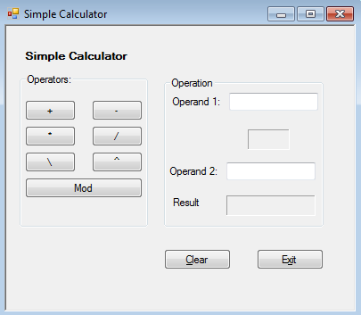

# 2. Write a program in vb.net to How to Reverse Set of Numbers.

# 3.Write a Vb.net program to design the following form, select the question number from combo box that question will be displayed into textbox and the options for that question will be displayed on four radio buttons, select option and click on submit button result should be displayed in another textbox.

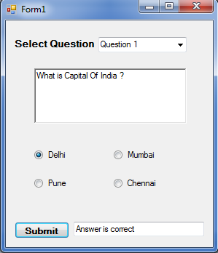

### 4. Write a Vb.net program to accept number from user into the TextBox. Calculate the square root of that number also convert the entered number into binary number and display result into the Message Box

5.Write VB program to find octal, hexadecimal, binary of given decimal number.

6. Write a program to find the sum, subtraction and Multiplication of two numbers using the function.

7. Write a program to reverse a number and check whether the given number is palindrome or not.

8. Create a program to find the Area and Parameter of a rectangle using the class and object in VB.NET.

9. Create a program to define the default constructor and parameterized constructor in a VB.NET programming language.

10. Create a program to understand the concept of Inheritance in VB.NET.

11. Create and implement an instance using a class in VB.NET.

12. Create a program to handle an exception using the Try, Catch, and Finally keywords for dividing a number by zero in VB.NET programming.

13. Create a program to display the multiple windows in the [VB.NET](https://www.javatpoint.com/vb-net) Windows Forms.

14. Create a simple program to understand the use of Timer Control in the VB.NET Windows Forms.

15. Write VB program that moves image left or right using click event.